**Using Gamification to Enhance Student Development Teaching and Learning**

**Kristina Ierardi**

**Community College Leadership Academy**

Abstract

This paper describes the process of a new student Orientation program redesign, by Cape Cod Community student development staff, to teach time management, semester course load recommendations, and strategies for success in college through the use of games and gamification, in order to increase student engagement and learning, as well as ultimately improve student retention, graduation rates and transfer rates. The foundations of gamification are explored, as well as their application to various industries for engagement, motivation, learning and problem solving. Game design and gamification recommendations are applied to the program redesign and incorporate specific Enrollment Management and Advising Services goals and student learning outcomes.

Background and Need

Cape Cod Community College’s Vision Statement and Strategic Plan both emphasize the College’s use of “innovation” to champion “student success.” As such, CCCC is interested in identifying and utilizing innovative methods to engage students and motivate action, particularly to improve “student success outcomes of retention, graduation and transfer” (CCCC Strategic Plan, p. 22). Recently, with the implementation of a new funding formula for public higher education in Massachusetts, the stakes for increasing retention, graduation and transfer rates have increased and now directly impact the College’s budget (Bombardieri, 2013).

Cape Cod Community College graduation rates indicate that students are not reaching this particular degree attainment measure of success in large numbers. In 2011, NCES Integrated Postsecondary Education Data System (IPEDS) data revealed that Cape Cod Community College ranked fourteenth out of the fifteen Massachusetts public community colleges, in graduation rates (Game Changer State Data, 2013). CCCC's rates reflect a larger, national problem. Poor graduation rates are common in community colleges. Complete College America reports that only 4.4% of community college students graduate in two years and according to the Community College Research Center at Teachers, College Columbia University, only 22% of first-time, full-time students at community colleges (Horn, 2015) graduate in three years.

This problem has drawn both local and national attention and concern. The Massachusetts Vision Project and President Obama's America's College Promise initiative were both prompted by the gap between the number of jobs requiring bachelor's degrees by 2020, and the number of projected educated workers eligible to fill expected workforce needs. By 2020 it is expected that 72% of jobs in Massachusetts will require a bachelor's degree (Within our Sights, 2013, p.7) and nationally “an estimated 35 percent of job openings will require at least a bachelor’s degree and 30 percent will require some college or an associate’s degree” (The White House, 2015). Currently, 53% of adults in Massachusetts have an associate’s degree or higher (Time is the Enemy, 2011, p. 125) indicating a 22% skills gap between current and projected needs. The state’s projected total growth of associate degree graduates and baccalaureate degree graduates indicates a projected total need of an estimated 5,000 additional associate degree graduates and 5,000 additional baccalaureate degree graduates to meet workforce demands, by 2020 (Degrees of Urgency, 2014, pp. 42, 43). As the American Association of Community Colleges phrases it, “A highly educated population is essential for economic growth and a strong democracy” and to meet that need, community colleges must “redesign students’ educational experiences, reinvent intuitional roles and reset the system so it better promotes student success” (Empowering Community Colleges, 2014, p. 3).

Retention rates and transfer rates at Cape Cod Community College are also low. Institutional data shows the College’s retention rates, at about 55% for First Time, Full Time, Degree Seeking students, lag behind the state average of 59%. Furthermore, since 2007 the College has seen completion rates of students under age 20 decrease (Massachusetts Board of Higher Education, 2010). Cape Cod Community College’s overall transfer rate in 2009 was 24%, increasing to 27% in 2011 (Cape Cod Community College, 2012).

In April, 2015, guided by campaigns to increase college retention and completion; to meet workforce demands, such as Complete College America and the Massachusetts Vision Project, Cape Cod Community College underwent an administrative reorganization. Enrollment Management and Advising Services, in particular, underwent major changes in staff and structure to support retention and completion objectives. Emphasis at the College has shifted to assisting entering and first semester students, in particular, to become better prepared for college success.

One of the key changes in Cape Cod Community College’s Enrollment Management and Advising Services plan is implementing a recommended practice and slogan from Complete College America to advise students to enroll in fifteen credits or five college-level courses, each semester, to finish an associate degree within two years; titled “15 to Finish.” Complete College America’s research shows that 62% of community college students complete a two-year associate degree when they take 30 or more credits in their first year (Four-Year Myth, 2014, p.22). In the Fall 2014 semester, 29% of Cape Cod Community College students (2,713) enrolled on a part-time basis (Enrollment Quick Facts, 2014). This is identical to national trends (The Game Changers, 2013, 25). Seventy-one percent of our students are part time and “Part-time students rarely graduate. Even when given twice as long to complete certificates and degrees, no more than a quarter ever make it to graduation day” (Time is the Enemy, 2011, pp. 3, 4). Therefore, the College is implementing this cultural and advising shift to recommend a fifteen credit course load, effective immediately.

Orientation, given its prominent ability to impact entering students, became recognized as an opportune vehicle to better prepare new students for college success, spread the “15 to Finish” concept, and ultimately impact Cape Cod Community College’s goals of increased graduation, retention and transfer. In March 2015, Cape Cod Community College’s Orientation Committee met to discuss the Summer 2015 new student Orientation programs. Committee members examined 2014 Orientation program evaluations, which revealed areas for improvement within the program. Evaluations indicated that the Overall Orientation rating ranged from 37% - 62% of attendees selecting Very Good, with an average of 51% selecting Very Good on different Orientation dates. Just over half of the Orientation attendees seemed to benefit a great deal from the event. Additionally only 45.5% indicated a Very Good level of the program's Overall Helpfulness, with the remaining number of respondents rating it lower, including 6.25% rating it Fair (Orientation Evaluations, 2014). While not dismal, these statistics certainly identified areas for improvement. Replacing the outdated opening video was a specific recommendation. Furthermore, the forced choice workshops were reevaluated by staff, since many entering students needed content from all three, student success, transfer counseling and career decision making content areas.

At this meeting I proposed formation of an Orientation sub-committee to redesign the portion of Orientation previously devoted to the student success, transfer and career decision making workshops. I was joined by Student Success Coordinator for First Year Programs, Sally Cohen and Transfer Coordinator, Mary Olenick. A short time later, GPSTEM grant Career and Placement Specialist, Alex Russo and GPSTEM Academic Advisor Colleen Coughlin also joined our initiative. Additionally, the new Director of Advising and Counseling, Lauren Folloni partnered with us to incorporate advising information into the program.

We began with a goal of making Orientation more engaging and informative. We were interested in teaching student success strategies, including encouraging several meetings with an academic advisor, career counselor and transfer counselor during the first semester to incoming students, in support of ultimately increasing retention, graduation and transfer goals of the College. After our first meeting and after consulting with colleagues in Enrollment Management and Advising Services, Learning Support Services and Student Life and Co-Curricular programs, we devised a list of 24 intended student learning outcomes (Appendix A) including a focus on teaching time management and emphasis on enrollment in a full-time course load of 15 credits per semester using the slogan “15 to Finish,” as suggested by Complete College America. Intent on utilizing innovative practices suggested by the College’s Vision statement the Strategic Plan, the use of gamification was elected to enhance student development teaching and learning at Orientation.

Gamification Rationale

Candy Crush, Words with Friends, Call of Duty, Minecraft and FarmVille are just a few examples of technologically based games with viral appeal in pop culture. While still considered trivial or mindless to some, there is growing research and a forceful movement at hand examining and applying the elements and frameworks of games to wider applications and industries, including higher education, for serious benefits. Gamification, as it is termed, is the concept of "using game-based mechanics, aesthetics and game thinking to engage people, motivate action, promote learning, and solve problems" (Kapp, 2012, p. 10).

Games have wide appeal and are extremely popular. Games have been in existence since ancient times, largely because they are fun and people enjoy playing them. In a game, "everything has the potential to be fun...In fact, four of the most popular games in the past decade include such thrilling activities as planting crops (FarmVille), waiting tables (Diner Dash), diapering a baby (Diaper Dash), and doing other people's hair and nails (Sally's Salon)" (Ziecherman & Cunningham, 2011 p. 2). Why? "The answer is simple: it is the mechanics of the game -- not the theme -- that make it fun" (p. 2).

Often it is thought that games are only popular among younger generations or within male-dominated, tech circles. However, statistics show otherwise. "A study by the U.S. Entertainment Software Association (ESA) found that the average gamer is thirty-seven years old (Shea, 2014, p. 7). Furthermore, “women are playing more and more games, and so is the older generation. It’s a relatively small increase but women now account for 47% of U.S. gamers, up from 42% in 2012...29% of gamers are over the age of 50,” (Galarneau, 2014). Because of their popularity across gender and age demographics, the Orientation sub-committee believed games and gamification would appeal to a broad spectrum of incoming students.

In recent years, there has been a growing surge in game play, due to advances in technology. In particular, mobile technology and app games have contributed to the ease and increase in game play. "The advent of mobile technology made gaming-on-the-go a standard in devices such as smartphones and digital tablets" (Shea, 2014, p. 10). Each day over 30 million apps are downloaded to mobile devices, the average number of apps downloaded to every iPhone/iPod touch and iPad is more than 60, and many of them are games (Wolfe, 2011).

The popularity of gaming also shows no signs of slowing down. The mobile gaming industry currently produces more than $24 billion dollars annually; more than twice as much as the movie box office industry (Galarneau, 2014). It is predicted that the gaming industry will push above $100 billion by 2017 (Brightman, 2014).

Games are now also growing into new markets, including restaurants and apparel, while gamification is becoming its own market. Heinz ketchup has teamed up with Trivial Pursuit to offer a Quick Response (QR) code game link on the back of restaurant ketchup bottles for game play while dining. Chili's restaurants have also added a gaming Ziosk to tables for customers to play up to 30 play games while they eat. Sketchers just released a version of game sneakers for gaming-at-your-feet accessibility.

Corporations are also making use of games and gamification for training and rewarding employees. The Gartner Group forecasts that more than 70% of the world’s biggest companies are going to use gamification this year alone (Hooptap, 2015). Gamification developers are also becoming highly sought after consultants. Bunchball is one such developer of gamification platforms for businesses. Bunchball chief executive officer Jim Scullion states *“*Gamification is an excellent way to effect and sustain change" (Shea, 2014, p. 10).

Essentially, company training programs are using games and gamification to teach.

*Games in our training programs are not a break from learning - they are learning. They are everything we say should be a part of great instructional design. They engage the learner, are interactive, and they enable the learner to get immediate feedback and to demonstrate mastery. Gamification, when done correctly, focuses learners on overcoming challenges, taking on important roles and overcoming obstacles during the learning process. Gamification can lead to higher order thinking skills and toward a focus on engagement and immersion of the learner— two elements critical to longer term retention and application of knowledge* (Kapp & Cone, 2014, p. 3).

Games and gamification are fast become popular teaching and training options because they have the ability to engage and motivate, two of the key factors sought by the CCCC Orientation sub-committee planners. “It motivates and engages people, changes their behaviours, helps to develop specific skills or overcome problems, inspires them to repeat tasks and it also turns the most boring situations into engaging activities (Hooptap, 2015).

Games motivate by capitalizing on our innate desire to achieve, "Individuals naturally (based on the inherent reward structure of nature) strive for achievement and, when rewarded, will continue to strive for more and greater levels of success" (Chapman, 2012, p. 35). Games provide a unique platform where gamers can feel a sense of accomplishment, while utilizing “their creativity in developing and optimizing certain strategies. They want these feelings enough that anything that stands in the way, be it grunt work or otherwise, is worth doing and doing urgently (Chou, 2014, p. 6). That sense of achievement is also reinforced biologically, "In addition to physical rewards for effort, our brain's dopamine release response is triggered as we exert effort, resulting in chemical reward as well" (Chapman, 2012, p. 35).

Essentially there are four reasons why people play games, for mastery, to destress, to have fun and to socialize (Ziecherman & Cunningham, 2011, p. 20). However the benefits of gaming can stretch far beyond the initial attraction.

Empirical studies published in peer-reviewed journals are now verifying the benefit of gamification in teaching. Karl Kapp, professor of instructional technology in Bloomsburg University’s Department of Instructional Technology in Bloomsburg, Pennsylvania, compiled a meta-analysis of studies in his book *The Gamification of Learning and Instruction*. He highlights the impact of several studies. He spotlights research conducted by Randel, J.M, Morris, B.A, Wetzel, C.D. & Whitehill, B.V. (1992) that examined 67 studies, and found that 56 percent showed no difference between games and conventional instruction, 32 percent favored games while 5 percent favored instruction. Another researcher, Wolfe, J. (1997) examined seven studies that showed game-based approach produced significant knowledge-level increases over the conventional case-based teaching methods. Finally, Sitzmann, T (2011) examined 65 studies using simulation games and found a 20 percent higher confidence level with games than traditional teaching methods, an 11 percent increase in declarative knowledge for trainees taught with simulation games, a 14 percent increase in procedural knowledge with simulation games and retention increased 9 percent (Kapp, 2014, pp. 78, 79).

Other studies are finding that "Instructional games seem to foster higher-order thinking such as planning and reasoning more than factual or verbal knowledge" (p. 102). In medicine, one study found that "surgeons who were active video game players made 32 percent fewer errors, performed 24 percent faster, and scored 26 percent better overall" (p. 102).

Another medically related development came from Firas Khatib, a postdoctoral researcher at the David Baker’s Laboratory in the Biochemistry Department at the University of Washington. After a fifteen year long struggle to “decipher the complex structure of an enzyme that exhibits behavior similar to that of an enzyme in the development of AIDS from an HIV infection” (Puiu, 2011), Khatib created an online game called Foldit to engage a community of scientists and their expertise in the search. Foldit was designed to have players competitively fold the best proteins to predict the structure of a protein. "Khatib's gamers took just three weeks to find the structure of the protein" (Shea, 2014, p. 38).

Dr. Jane McGonigal is a leading proponent of games and gamification. Her research, in collaboration with the University of Pennsylvania and SuperBetter Labs, is studying the effects of games on depression. “A six-week trial of the mobile game SuperBetter yielded positive results: for the typical player, the game eliminates six symptoms of depression in six weeks” (McGonigle, 2015). She believes games have the power to do this and much more “games can boost our resilience, help us experience post-traumatic growth, and even give us 10 extra years of life” (McGonigle, 2012). Her book *Reality is Broken* explores the use of games for collaboration and world problem solving. She is convinced and convincing in explaining that games are the single most important way we can spend our time (McGonigle, 2011).

The environment of games allows for such tremendous learning opportunities, as it provides an opportunity to fail and develop mastery, without real penalty. Additionally, "Games provide motivation to succeed and reduce the sting of failure" (Kapp, 2014, xxi). Time can also be sped up in game situations, so progress and big picture concepts can be understood and mastered in minutes or hours, allowing for increased efficiency and expanded learning in shorter time frames or instantly applying long-term rewards or outcomes. Finally, with the ease of sharing games in the form of apps, games can be replayed frequently to continue teaching and the quest for mastery beyond the initial class or Orientation program. In these ways, games and gamification provide a tremendous resource for learning and higher education.

Gamified Program Design and Game Design

I led the sub-committee’s efforts to research game design, gamification and video game development. The process began with research on each subject area and Orientation best practices, followed by contemplation and conversations with a cross section of colleagues to identify desired student learning outcomes. Just as in curriculum design, “The more detailed and discrete the objectives are defined, the better the building blocks of gamification can be laid” (Chapman, 2012, p. 142).

Time revealed itself as a major focus area for teaching and learning. We set out to convey the time management skills as well as prescribe percentages of time recommended for course enrollment and study associated with each course. We were encouraged to learn that in Connecticut, “Full-time enrollment in community colleges increased dramatically when colleges began using full-time enrollment status as the default when processing student financial aid applications. The strategy shows students that attending college full-time is often more affordable than they expect” (Time is the Enemy, 2011, p. 13).

We also combined our collective experience and knowledge of student development best practices into development of game components. We combined elements from Astin’s theory of student involvement which connects retention to participation in college-sponsored activities (Astin, 1985), with John Bean’s ideas that student goals and expectations contribute to student persistence (Bean, 1980). Furthermore, we incorporated the importance of academic advising as national data from the Noel-Levitz Student Satisfaction Inventory finds advising to be the most important factor to students in retention and college satisfaction (Noel-Levitz, 2005). Additionally, we incorporated George Kuh’s recommendations for collaborative learning into the gamification of the process. (Kuh, 2008). We also incorporated the concept that internships (Friedman, 2014) and networks (Jacobs, 2013) lead to long-term success in the workplace into the game. Furthermore, the specific recommendation from Complete College America to complete math in the first semester (Complete College America, 2011) was also applied. Colleagues also contributed ideas for incorporation; particularly around tutoring, technology and financial aid. We compiled this information to generate a series of components to deliver through the game and gamification experience.

We also researched and embedded game design and gamification best practices. We looked specifically at game mechanics, game dynamics and aesthetics.

Game mechanics include the elements and functioning components. “Game elements that should be incorporated into the field of learning and instruction are elements like continual corrective feedback, storytelling, challenge and the freedom to fail. Creating instructional games with those elements is what makes gamification effective and instructive” (Kapp & Cone, 2014, p. 3). Basic elements and considerations include: system; players; rules; challenges; pieces/avatar; abstraction of reality essence, but not its exact replica; point systems/scores/reward structures including badges; feedback structures and time constraints.

Game dynamics defines the players’ interactions with the mechanics. Best practices are aimed at optimizing human motivation (Chou, 2015, p. 10) and include empowering users to make choices and control outcomes (Chapman, 2012, p. 82), as well as incorporating a combination of conflict, competition, and cooperation (Kapp, 2014, p. 31). Setting challenges with achievable tasks is highly recommended. Games have to be easy to play for everyone, yet with a progression of difficulty over the course of the game, so it is not deemed too hard or too easy and maintains the interest of a broad spectrum of players (Hooptap 2015). Reward recommendations included: “Reward players for boring tasks and give them feedback for interesting ones” (Kapp, 2014, p. 223) and “Use measurement achievements instead of completion achievements to increase intrinsic motivation through feedback” (p. 222). Borrowing from operant conditioning researchers, Pavlov and B.F. Skinner, it is recommended to vary the delivery schedule of rewards for maximizing motivation (Ziecherman & Cunningham, 2011, p. 18).

Game aesthetics describe how the game makes the player feel. The term summarized engaging, well-crafted graphics as well as a well-designed experience. Best practices include avoiding cutesy graphics and themes, but recommended using metaphors, just as the Olympics use precious metals to symbolize levels of achievement (p. 3). We utilized this concept in developing the idea of a plate being full as a symbol of time management and henceforth developed the food on the plate theme.

The recommendation that realism of graphics is not necessary, “A game doesn’t need to have photorealistic images to be visually appealing” (Kapp, 2014, p. 47) was somewhat of a relief. However in keeping with ethical practices, we only incorporated our own images or public domain images not requiring attribution for our site (Cross, 2015, p. 73). We also recognized that while aesthetics are not everything “they can lift a good experience into a great experience” (p. 47).

I researched several video game development software systems, including Unity and GameSalad. Both were free, highly effective, and came with hundreds of YouTube video and online training resources. GameSalad was ultimately chosen for its ability to create games without coding. I also researched popular games and drew up several design templates to incorporate game components while minimizing the need for user gaming talent and control familiarity. In the end, the Alphabeats game app served as the inspiration for our game design.

The sub-committee met several times to plan the game theme, as well as the process of incorporating the game into the Orientation program. In these program development meetings, we also came up with additional gamification ideas, including: trivia, teamwork and competition, as well as a learning evaluation feedback in the form of a quiz. We decided to incorporate PollEverywhere technology (reception dependent) to further incorporate gamification and engagement into the process. An outline and rough draft of the program (Appendix B) were developed and shared with members of Enrollment Management and Advising Services, Student Life and Co-Curricular Programs and Learning Support to solicit feedback and further suggestions.

We also conceptualized reinforcing the message components emphasized at Orientation in a visually appealing and informative infographic using Piktochart. Just as badge collection within the game is desirable, we brainstormed for ways to incorporate actual badge awards for actual completion of recommended success strategies, such as a passport type stamp for actually using the Cape Cod Community College Tutoring Center or meeting with an advisor, into our student development processes utilizing the Piktochart infographic. “A combination of progression and the award of virtual ‘badges’ is fast becoming one of the most popular ways to gamifying an activity and create stickiness and drive longer term loyalty” (Chapman, 2012, p. 170).

Then, theme fulfillment and game development in GameSalad began in earnest. Royalty-free, public domain images, to shape the aesthetics of our game, were located, downloaded, resized, and made to have transparent backgrounds before they were assigned to “actors” in GameSalad. Video tutorials and the *Learn Mobile Game Development in One Day Using Gamesalad* manual were thoroughly digested and programming commenced. Special attention was given to the development of game scoring logistics.

On July 21, 2015 Cape Cod Community College will hold the first new student Orientation for the Fall 2015 semester. The gamified Orientation program including the unveiling and playing of the video game app, *GraduPlate*, created by the Orientation sub-committee members; led by Kristina Ierardi and co-programmed by Alex Russo, will be held. Three additional Orientation programs will repeat this experience in August and September 2015.

Learning evaluations and feedback will be collected regarding the game and gamification experience at each Orientation and analyzed by sub-committee members. The Student Life and Co-Curricular Programs staff will continue to conduct an overall Orientation evaluation, which will provide data for comparing previous Orientation programs with the redesigned model. Furthermore, as pre-registration and registration is required for each Orientation program, attendees can be traced over time and compared with non-attendees to evaluate impacts on graduation, retention and transfer, with the assistance from the office of Institutional Research and Planning.

Conclusions

Despite the burden of video game development resting predominantly on my shoulders, I find myself immensely inspired and motivated by the game development process and intellectual challenge. I believe acquiring and building upon these skills can add not only to the immediate Orientation program and long-term goals of graduation, retention and transfer, but will also prove to have applicability to many other areas of teaching and learning. I hope I am able to combine my creativity, technological skills and interest with education as I move forward in my career.

The relationships I have built with my Orientation Committee, Enrollment Management and Advising Services, and GPSTEM grant colleagues, combined with the excitement of this project have been the cornerstones for leadership and the formation of a committed group of, already busy, volunteers. I definitely noticed the Process Structure of leadership at work here, as suggested by Margaret J. Wheatley in my Community College Leadership Academy book group on *Leadership in the New Science*. There was no hierarchy to this group, but rather a powerful mission that guided us. For different portions of the project new leaders rose up to the challenge. For instance Sally Cohen and Alex Russo led the process of incorporating trivia into an opening, movie inspired Emaze presentation, while Colleen Coughlin led the development of the Piktochart. I find this structure of leadership and its collegiality to be the most enjoyable and least problematic.

The mission behind this project, to increase retention, graduation and transfer rates of community college students is a serious matter. It is understood that “Unless we move with urgency, today’s young people will be the first generation in American history to be less educated than their predecessors” (Time is the Enemy, 2011, p. 2). Yet, the solution we chose to teach specific student development learning outcomes; gamification, was one designed to increase fun and engagement, as well as learning. So, while the mission guided us, the journey itself was enjoyable. I am hopeful that the use of gamification will expand in higher education and will prove successful at Orientation and in other areas of incorporation.

References

American Association of Community Colleges. (2014). *Empowering community colleges to build*

*the nation’s future: An implementation guide.* Washington, DC: Author. Available at

www.aacc21stcenturycenter.org

Astin, A.W. (1985). *Achieving academic excellence.* San Francisco: Jossey-Bass.

Bean, J. (1980). *Dropouts and turnover: The synthesis and test of a causal mode of student*

*attrition. Research in Higher Education*.

Bombardieri, Marcella. (2013, August 12). Mass. ties community college funding to result. *The*

*Boston Globe*. Retrieved from http://www.bostonglobe.com/metro/2013/08/11/state-ties-community-college-funding-students-improvement/J8BOFMPu3BvjGXBi4DzTdL/story.html

Brightman, J. (2014, January 14). *Mobile gaming to push industry above $100 billion by 2017.*

Retreived from http://www.gamesindustry.biz/articles/2014-01-14-mobile-gaming-to-push-industry-above-usd100-billion-by-2017

Cape Cod Community College. (2014). *Cape Cod Community College Enrollment Quick Facts.*

West Barnstable, MA: Cape Cod Community College Institutional Research and Planning. Retrieved from http://www.capecod.edu/c/document_library/get_file?uuid=adb23cec-0679-4fa6-8532-20ca16ec7fa2&groupId=10625

Cape Cod Community College. (2014). *Orientation Evaluations 2014.* West Barnstable, MA: Cape

Cod Community College Office of Student Life and Co-Curricular Programs

Cape Cod Community College. (2014). 2914 *Strategic Plan.* West Barnstable, MA: Cape Cod

Community College Institutional Research and Planning. Retrieved from

<http://www.capecod.edu/c/document_library/get_file?uuid=228d07f5-2b5d-4215-baed->

02e231ffca7a&groupId=10625

Cape Cod Community College (2012). 2012 Five-year interim report to the New England Association of

Schools and Colleges (NEASC). Retrieved from: http://www.capecod.edu/c/document_library/get_file?uuid=ae64b489-1221-448b-8c33-752b21f098d9&groupId=1062

Chapman, P. (2012). *Gamification and game mechanics made simple: How to gamify your*

*organization for better performance, loyalty and revenue*. New York, NY: Nordic Press.

Chou, Y. (2014). *Actionable gamification: Beyond points, badges and leaderboard*s. Vancouver,

BC, Canada: Leanpub.

Complete College America. (2014) *Four-year myth, make college more affordable: Restore the*

*promise of graduating on time.* Indianapolis, IN: Complete College America. Available at

http://completecollege.org/wp-content/uploads/2014/11/4-Year-Myth.pdf

Complete College America. (2013). *Game changer state data, Massachusetts.* Retrieved from

http://completecollege.org/state-data-loader/?state=Massachusetts&code=ma

Complete College America (2013) T*he game changers: Are states implementing the best reforms to*

*get more college graduates?* Washington, DC: Complete College America. Available at http://completecollege.org/pdfs/CCA%20Nat%20Report%20Oct18-FINAL-singles.pdf

Complete College America. (2011) *Time is the enemy: The surprising truth about why America’s*

*college students aren’t graduating…and what needs to change*. Washington, DC: Complete

College America. Available at <http://completecollege.org/docs/Time_Is_the_Enemy.pdf>

Cross, J. (2015). *Learn mobile game development in one day using Gamesalad.* CreateSpace.

Friedman, T. (2014, September 14). It takes a mentor*. Cape Cod Times.*

Galarneau, L. (2014, January 16). *2014 global gaming stats: Who’s play what, and why?*

Retrieved from

http://www.bigfishgames.com/blog/2014-global-gaming-stats-whos-playing-what-and-why/

Hooptap. (2015, April 2). *The truth about gamification.* Retrieved from

http://www.slideshare.net/Hooptap/the-truth-of-gamification

Horn, M. B. (January 21, 2015). *Obama, free community college may not work*. *CNN.*

Retreived from http://www.cnn.com/2015/01/20/opinion/horn-community-college/

Jacobs, D. L. (2013, March 22). The six best ways to find your next job. *Forbes*. Retrieved from

# <http://www.forbes.com/sites/deborahljacobs/2013/03/22/the-six-best-ways-to-find-your-next-job/>

Kapp, K. M. (2012). *The gamification of learning and instruction: Game-based methods and*

*strategies for training and education*. San Francisco, CA: Pfeiffer.

Kapp, K. M. & Cone, J. (2012). *White paper: What every chief learning officer needs to know*

*about games and gamification learning.* Bloomsburg, PA: Institute for Interactive Technologies.

Kuh, G. (2008). *High-Impact educational practices: What they are, who has access to them,*

*and why they matter.*

Massachusetts Board of Higher Education (2010, December). *Massachusetts Community Colleges:*

*Key Performance Indicators Linear Trends*. Retrieved from

http://www.mass.edu/library/Reports/2010-03CCTrendBook.pdf

McGonigle, J. (2015). *Research: Clinical and randomized control trials.* Retrieved from

http://janemcgonigal.com/learn-me/

McGonigle, J. (2012). *The game that can give you 10 extra years of life.* Available at

https://www.ted.com/talks/jane_mcgonigal_the_game_that_can_give_you_10_extra_years_

of_life?language=en

McGonigal, J. (2011). *Reality Is Broken: Why Games Make Us Better and How They Can Change the World*. New York: Penguin.

Noel-Levitz. (2005). *Advising Partnerships for Student Success University of Maryland Eastern*

*Shore The Goals for Today’s Discussion.* Retrieved from

[https://www.umes.edu/WorkArea/DownloadAsset.aspx?id=2361](https://www.umes.edu/WorkArea/DownloadAsset.aspx?id=23618)8

Puiu, T. (2011, September 20). *Gamers solve decade old HIV puzzle in ten days.*

Retreived from <http://www.zmescience.com/research/studies/gamers-solve-decade-old-hiv-puzzle-in-ten-days/#ixzz3azjOGzH0>

Shea, T. (2014). *Gamification using gaming technology for achieving goals*. New York, NY: The

Rosen Publishing Group, Inc.

The Vision Project. (2014, October). *Degrees of urgency: Why Massachusetts needs more college*

*graduates*. Boston, MA: Massachusetts Department of Higher Education.

The Vision Project. (2013, October). *Within our sights: Inside campus work to achieve national*

*leadership in public higher education*. Boston, MA: Massachusetts

Department of Higher Education.

The White House. (2015, January 9). *Fact Sheet - White house unveils America’s College Promise*

*proposal: Tuition-free community college for responsible students*. Washington, DC: The

White House, Office of the Press Secretary.

Wolfe, B. M. (2011, January 20). *The number of apps downloaded each day reaches 30 million*.

Retreived from

<http://appadvice.com/appnn/2011/01/number-apps-downloaded-day-reaches-30-million>

Zichermann, G., & Cunningham, C. (2011). *Gamification by design*. North Sebastopol, CA:

O’Reilly Media, Inc.

Appendix A

**EMAS Orientation Student Learning Outcomes**

Success

* Students will learn how to move their student email to their phone
* Students will understand the importance and their responsibility for checking their student email
* Students will gain understanding of time required to balance school courses and homework with other responsibilities
* Attendees will visually represent/graph a 168 hour week with time allocations for activities
* Students will learn number of hour required to study for each hour of class
* Students will learn who their advisor is and where their office is located and their go-to resource
* Students will learn how many times they should meet with their advisor each semester and for what specific purposes they should meet with their advisor
* Students will learn about the importance of campus engagement for success
* Students will learn about resources and clubs/activities to boost their engagement, grades and success
* Students will learn that five classes is a full time course load “15 to Finish”
* Students will learn that taking less than five classes a semester or completing pre-collegiate level courses will take longer than two years
* Students will learn that not being successful in classes may negatively impact financial aid
* Students will learn that students who want to get better grades will use tutoring and math lab or writing center
* Students will learn that they will have choices to make and obstacles to overcome
* Students will learn that showing up and reading syllabus are two keys to success
* Students will learn that any time they change their schedule, go to Financial Aid

Transfer

* Students will learn about transfer counseling services
* Students will learn about MassTransfer and other transfer options
* Students will learn when and how frequently they should meet with a transfer counselor

Career

* Students will learn about career counseling resources and services
* Students will learn to take a career assessment, to research careers, to informational interview and to promote themselves as well as resources for these activities
* Students will learn to narrow career goal to academic focus area
* Students will learn to get part time/seasonal job/volunteer related to career
* Students will learn that internships are offered in some programs
* Students will learn that networking is the number one job search strategy and they should start networking in college
* Students will learn that introducing themselves to fellow students, faculty, staff, joining clubs/activities, attending Networking events and joining LinkedIn are great ways to start networking

Appendix B

Orientation Program Draft

**Summer 2015 Orientation Plan Details**

Tilden Arts Studio Theatre

Dates:

* Tuesday, July 21 2015 at 10:00 am (10:15 – 11:15 our portion)
* Monday, August 31, 2015 at 10:00 am (10:15 – 11:15 our portion)
* Tuesday, September 1, 2015 at 10:00 am (10:15 – 11:15 our portion)
* Wednesday, September 2, 2015 at 10:00 am (10:15 – 11:15 our portion)

Upon Entering Updates:

* Popcorn popping (sign a commit form that we hang to get popcorn)
  + Have students respond with texts to PollEverywhere trivia to get them warmed up to PollEverywhere in movie presentation opener
  + Student Life and Co-Curricular programs will also have water and refreshments
* Movie theatre pictures, promos and trivia on screen
* Club information listed and around
* MassTransfer information
* Career Start-Up Guide packets available
* Piktochart Take-a-ways

10:00 David Biggs Welcome and Student Life & Co-Curricular Programs

10:10 President/Vice President Welcome

10:15 Us

1. **Welcome and Introductions**

* Welcome to College! Welcome to Cape Cod Community College. And, welcome to our studio theatre where numerous theatrical productions and classes take place (have cool lighting on).
* Hello! Introductions Sally, Kristina, Mary, Alex, Colleen, Lauren…
* Now introduce yourself to the people sitting next to you. Say hello, tell you’re your name. Introducing yourself to your classmates and faculty members is key to building your network, which will help you succeed in college and be your number one resource for finding jobs when you are ready! Be sure to introduce yourself to faculty and classmates in each of your classes. Be the first to say Hello! Start practicing now.
* PollEverywhere questions
  + How many of you are right out of high school?
  + How many of you have been to college before?
  + Where are you from (a. Cape Cod, b. Martha’s Vineyard, c. Nantucket, d. Plymouth, e. Wareham, f. Southeastern MA, g. farther) t-shirt or give-a–way to farthest traveler
  + Was Cape Cod Community College your first choice?

1. **Congratulations**

We want to congratulate all of you on choosing Cape Cod Community College. You have made a very smart decision to join 11 million students; that’s 45% of all college undergraduates, across the country and enroll at a community college (AACC).

* Kudos for deciding to save $5,000 - $50,000 (an average of $25,000) this year on your college tuition and fees! According to U.S. News & World Report, “the average tuition and fees at private schools was $31,381 in 2014 – 2015.” With some colleges and universities charging over $50,000 in tuition and fees alone. The Public Higher Education Network of Massachusetts (PHENOM) states that the average tuition and fees at public 4-year institutions in Massachusetts for FY14 was $10,792. Full-time (5 classes tuition and fees at Cape Cod Community College was only $5,265 in 2014 -15)
* Really you saved even more than that because if you took out a loan for $20,000 the cost of that loan over time, interest would accrue on the loan and it could easily amount to $120,000.
* So, again, congratulations on making such a wise choice with your money.

You’ve also chosen a college with small class sizes that are taught by accomplished professors, not teaching assistants, (26.5% with doctoral degrees and 72% with master’s degrees in their fields).

* These are two the most desired and beneficial learning environment factors in higher education.
* Since you are entering college, you have the potential to earn more money and enjoy a broader selection of higher paying, abundant job opportunities than workers without a college degree (<http://www.ruggersedge.com/downloads/college-power-bulletin/>) -- *show America’s Career Infonet most openings/high pay require degree* --

1. **What is your motivation?**

So, now that you are here, we want you to succeed. We want you to complete your degree or certificate and continue your education, as lifelong learners and possibly multiple degree earners.

And you have already made such good decisions, as we noted earlier, that it is obvious that you want to succeed. What is your motivation? Why are you here (poll everywhere or take responses from the audience?) What is your motivation to complete your degree?

1. **Not only do we want you to succeed,** Perhaps you also realize that:
   1. Cape Cod wants you to succeed (From 2000 to 2010, there was a 26% decline in Barnstable County residents age 25-44. This trend creates an imbalance in the fabric

of the community and a decrease in the educated workforce on Cape Cod that is detrimental to the economy and future of the Cape)

* 1. Massachusetts wants you to succeed (Vision project - Massachusetts is engaged in a fierce competition with other states and nations for talent, investment and jobs. The state’s primary assets in this competition are the overall educational level of our people and our workforce. Massachusetts is committed to increasing the number or college graduates)
  2. The United States wants you to succeed, so we can complete globally (the impetus for America’s College Promise is based on the fact that By 2020, an estimated 35 percent of job openings will require at least a bachelor’s degree – Massachusetts will the be the number one state for requiring a bachelor’s degree -- and 30 percent will require some college or an associate’s degree.) The United States workforce wants you to complete your degree to remain competitive and fill jobs.
  3. STEM employers want to to succeed to fill jobs (Data from the U.S. Bureau of Labor

Statistics (BLS) support that assertion. Employment in occupations related to

STEM—science, technology, engineering, and mathematics—is projected to grow to more than 9 million between 2012 and 2022. That’s an increase of about 1 million jobs over 2012 employment levels and many of these jobs require post secondary education, high skill levels and degrees)

 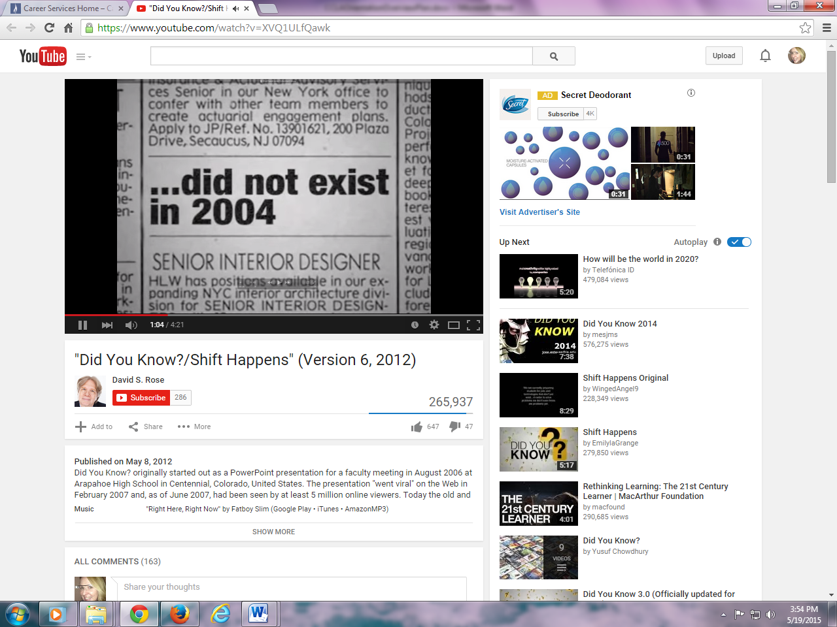 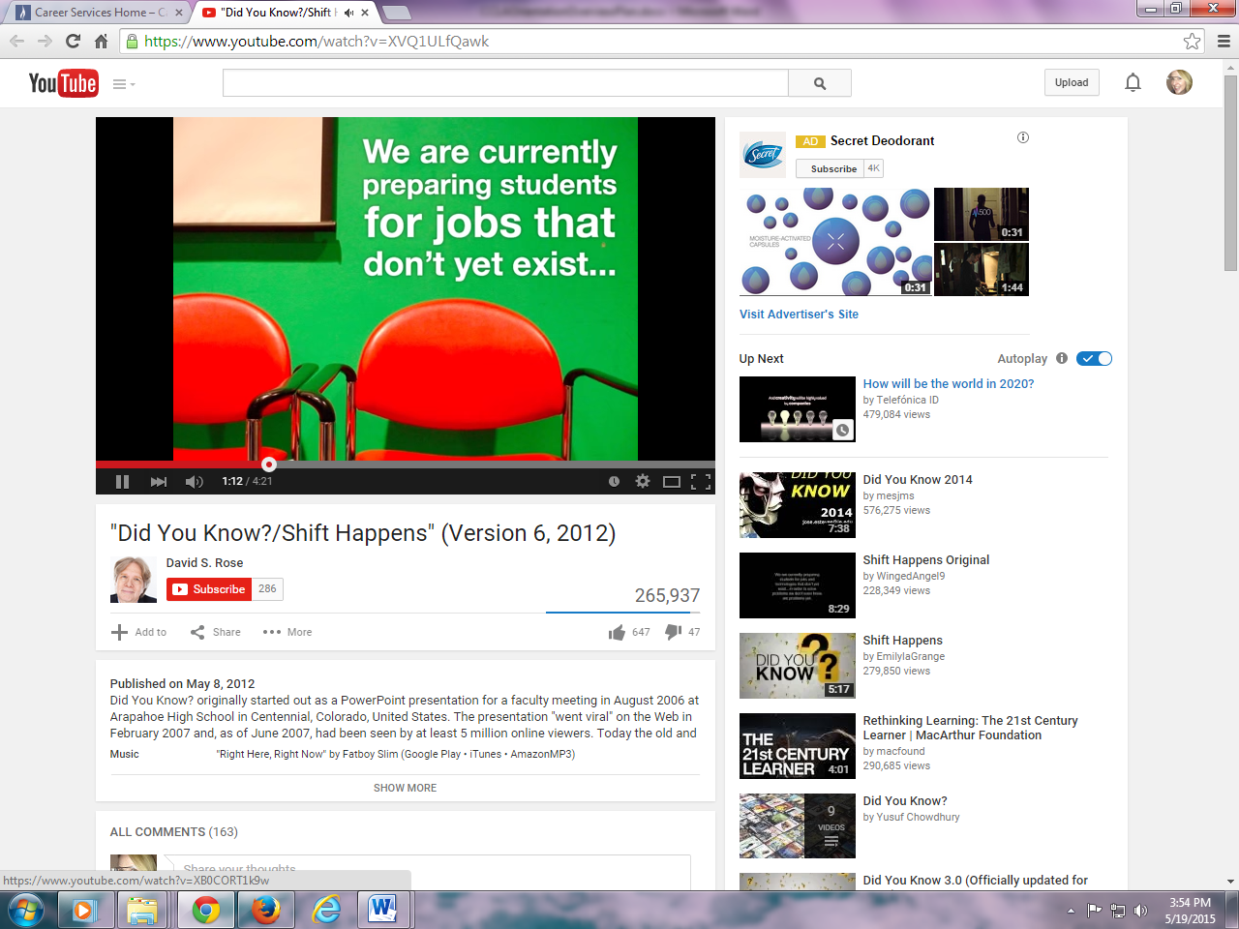 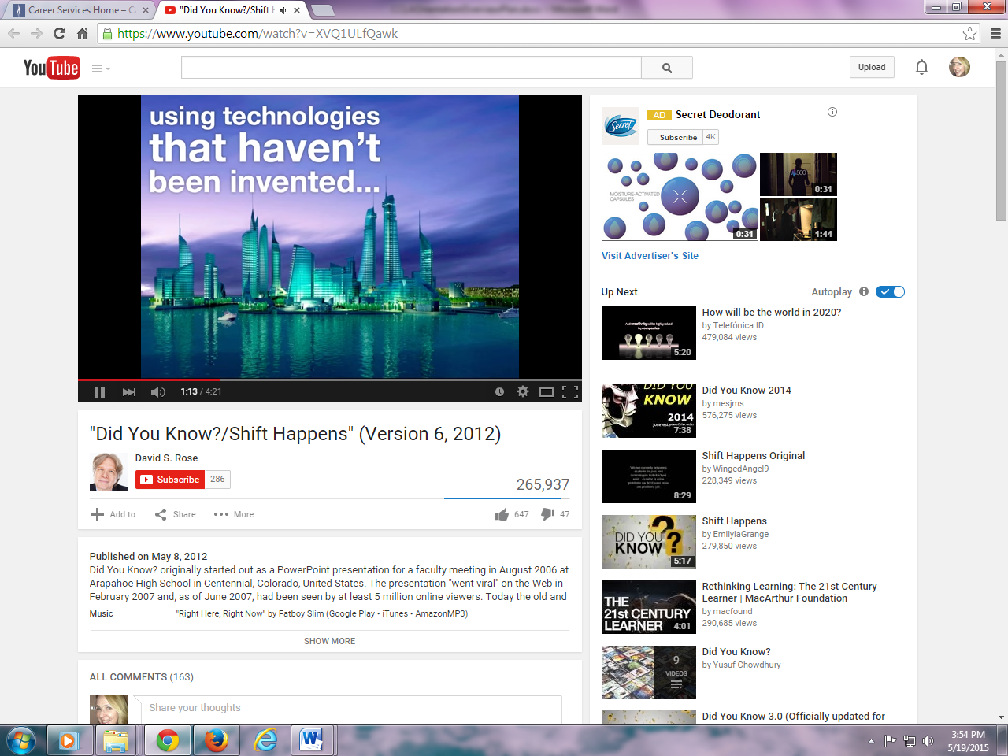 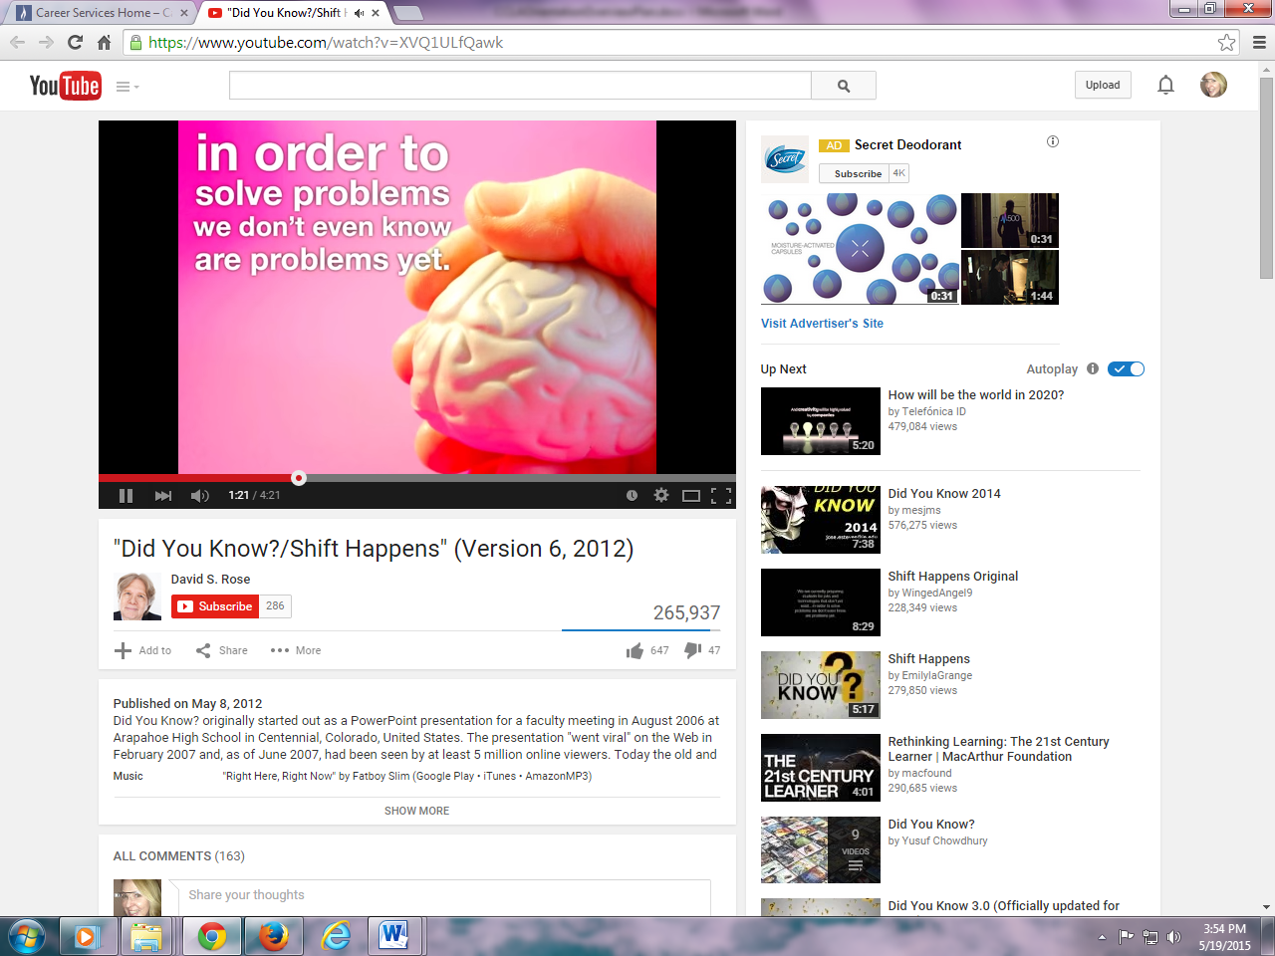

* The top ten jobs in 2010 did not exist in 2004. As the employment trend to require higher and higher levels of education continues, you will have the ability to compete globally; choose a better employer, work setting or project; or work for yourself and have the knowledge and credibility to attract clients.
  1. The world wants you to succeed (15 Global Challenges for humanity http://millennium-project.org/millennium/challeng.html) there are many problems that need to be solved, improvements to products and processes that need to be developed, new technology that needs to be created. The world is counting on you to come up with these, as well as solutions to those problems we don’t even know about, yet.

1. **Will you succeed?**
   1. Statistics show that across the country, only 4.4% of community college students will graduate in two years (Complete College America). Only 22% of first-time, full-time students will graduate with an associate degree in three years (Federal statistics).
   2. Don’t you want to defy those statistics and show them you will succeed?
   3. There are a lot of reasons that students leave college without completing, but some them include:
      * because they don’t know strategies for college success and
      * lack time management skills to balance academics, work, family responsibilities, social lives and other commitments
      * they fail to integrate into the college; finding a place to belong, meeting fellow students, faculty, advisors, and administrators
      * and they fail engage by joining clubs and organizations
2. **Success Strategies and GraduPlate**

We want to help you gain those strategies, skills and expectations of engagement and overcome those odds today, but we also want it to be fun.

* How many of you play games? PollEverywhere/hands
* What are your favorite games?
* Rather than lecture you on strategies, skills and expectations, we’ve applied gamification to the concepts that will help you succeed at CCCC in our new game app called GraduPlate.

1. **Things we want you to learn – Game Overview**

*GraduPlate instruction sheet and icon identifiers

*Time Management:*

* The Fall semester will run for 15 weeks. How many hours are there in a week? 168 hours each week x 15 weeks = 2,520. You have 2,520 between the start and the end of the semester, how are you going to fill them?
* How many classes are you going to take? You need to take five college-level courses to complete your degree in two years. Courses are typically three credits each, so that is 15 credits each semester. You will see and hear the slogan “15 to Finish” a lot. And it means take five classes each semester. Why?
  + full-time students are much more likely to graduate. According to Complete College America, only 7% of part-time students will finish their degree.
* If you are taking 5 courses a semester, each course will meet for 3 hours each week (four for some science/math/language). That is 15 hours of courses each week. 15 hours each week x 15 weeks = 225 hours in class.

*Tip: Students will learn that showing up and reading syllabus are two keys to success*

* How much are you going to study? Plan to study 2 – 3 hours for each hour of class time. So if you have 15 hours of class time, you should be studying 30 – 45 hours each week. 30 – 45 hours a week X 15 weeks, that is 450 – 675 hours of studying.
  + How much will it cost you if you don’t study enough?
    - Another semester of your time to retake the course, the cost of the course itself ($526.50)
    - You must still pay for the course you failed to successfully complete ($526.50)
    - the jeopardy of losing financial aid in future semesters for not meeting the ratio of successfully completed courses (You must receive passing grades in at least two-thirds (**67%**) of your "attempted credits" while at CCCC.)
    - your grade point average will be lower which could lead to academic dismissal, loss of scholarships (current or future) and loss of employment opportunities (employers want to hire the best)

*Tip: join a study group, and the tutoring center - students who want to get better grades (As and Bs) use the tutoring center, math lab and writing center.*

* Meet with your academic advisor frequently (3 – 5 times each semester) to learn about the College, select courses, ask questions, resolve conflicts, get good advice, complete forms, make sure you are on track to reach your goals and graduation requirements.

*Tip: If at any point in time you change the courses add, drop, make a switch, etc. Go to Financial Aid and see how that change will impact your funding.*

* Meet with a career counselor to take career assessments, research careers, decide on a career direction and map out how to get there, and craft a resume and online profile to get you there.
* Meet with a transfer counselor to find out where you want to go next. Learn about MassTransfer and how you can guarantee your admission and the transfer of your courses to the state colleges and universities in Massachusetts. Start planning this semester. And meet with your faculty members.
* Meeting with advisors and faculty members should only take about 15 hours of your time each semester.
* Get involved. Join a club. One hour a week for fifteen weeks about 15 hours per semester.
* Time on Basics:
  + You also need to eat, sleep, relax, exercise, meditate (1,075 hours)
  + Commute (about 30 minutes a day some may be longer/shorter = about 50)
  + Groom yourself, shower, personal care (30 minutes/day at least = about 50)
  + Time Left - That leads only 415 hours left in the semester:
* Work 140
* Sport/Hobby/volunteer 140
* Be with family and friends 135

15 hours

CCCC Club or organization

15 hours

to meet with Advisor, Career Counselor, Transfer Counselor, Faculty

50 grooming,

personal care

hours

50 commute

hours

415 hours

to divide between family, friends, work, hobbies, volunteer

1075

Nutrient hours (sleep, eat right, exercise, relax, meditate)

225

class hours

675

study hours

1. **Let’s Play**

Go to game. Let’s try it out.

**Directions**

* + The game is easy to play, you just move your plate left and right.
  + What is difficult is spending the right amount of time on the activities that will make you

successful. The first scene is one semester.

* + Just as we discussed, you want to try and put 225 hours of classes on your plate and 675 hours of study time, 1075 hours of time for sleep eating right, etc. You want to meet with your advisor five times and a career counselor 3 times, etc. And you will be rewarded for doing so. There will also be bonuses to collect and greater challenges in subsequent semesters.
  + If you are successful, you will go on to three more semesters and graduate with all 20 of your courses for your degree, strong grades, high employability or resume points, for having worked in your field, interned, volunteered, gained skills, and have a strong network, because networking is the number one job search strategy.

Break into teams to play against each other. – 10 minutes on game/3 minutes one semester

1. Evaluate Learning Quiz, what did you learn – 10 team questions, first team to finish, let’s check and see if you got them right – prizes?
2. Next Steps

* Download the app
* Actually do the things the game teaches, in real life. Go to an actual advisor, career counselor, transfer counselor, introduce yourself, and balance your school and other responsibilities wisely…

*Use the Piktochart to help you remember!

1. How do you know where your advisor is – Campus Web demo
2. Email!!!

* Your College email is so important, it is your job, it is where you will receive all communications about what you are supposed to do and when you are supposed to do it. You should never be saying “no one told me” you need to check your email that is where you will find it.
* Move your student email to your phone
* Check your email now to see if you have received the Orientation Certificate/Badge (we will have pre-sent with Orientation registration list) pull it up on email first to show gets prize!

1. Advising -The Advising Center, Your Advisor is your Go-To resource. If you do not know where to go or what to do, ask your advisor.

* Lauren, SDAT.